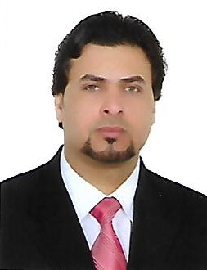

**Curriculum vitae**

|  |  |  |  |
| --- | --- | --- | --- |
| **personal information** | | | |
| **Name** | Ahmed Ibrahem ahmed | | |
| **Home** | Iraq – bagdad - palestine street | | |
| **Birth Date** 1980 -1- 31 | | | |
| **Marital status** | Married | Gender | Male |
| **Nationaly** | Iraqi | Religion | Muslem |

|  |  |
| --- | --- |
| **Education** | |
| Technical Institute / Department of Mechjanical Graduation year 2000 - 2001 | |
| Faculty of Rafidain university / Department of cooling and Air Conditioning Graduation Year 2010-2009 | |
| E-MAIL | Muhandes.ahmed 80@yahoo.com |
| Phone | 07711393828 |

|  |
| --- |
| Training courses – skills.Hobbies.Experiences |
| - Member of Iraqi Engineers Syndicate since 2011 practitioner-1.  - I have experience in auto parts of all kinds  And how to work on customer reception  - I have experience in computer field and I have experience in the following systems: Windows, Word, Excel and PowerPoint.  - I have experience in the field of maintenance of mobile devices in terms of technical software and hardware and hardware.  - I worked at several maintenance centers in Al-Rubaie Street and I have experience of at least 7 years and I have experience in smart phones :-  ( iphone -ipad - sony – Htc - Black berry – samsung - Huawei )  - I have experience in the specialist of engineering refrigeration and conditioning (in the maintenance of refrigeration and air conditioning).  - I have experience in installing the camera system. |

**Languages**

|  |  |  |  |
| --- | --- | --- | --- |
| **English** | **Read** | **Write** | **Speak** |
| Good | Good | Good | Good |